WELCOME TO MADELEY ACADEMY
Year 7 Transition Guide
For Year 6 Students and Parents




Madeley Academy
Castlefields Way
Madeley, Telford TF7 5FB

Welcome to Madeley Academy
Congratulations on being offered a place at Madeley Academy! Moving from primary school to secondary school is an exciting step. Our aim is to ensure every student feels safe, supported and ready to succeed.

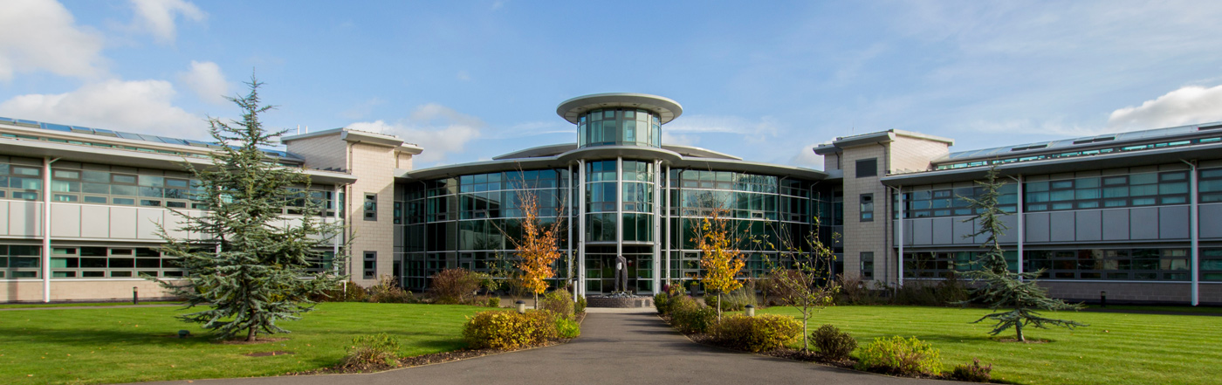

Our Values
✔ Respect for others
✔ High expectations for learning
✔ A supportive school community
✔ Opportunities for every student to succeed

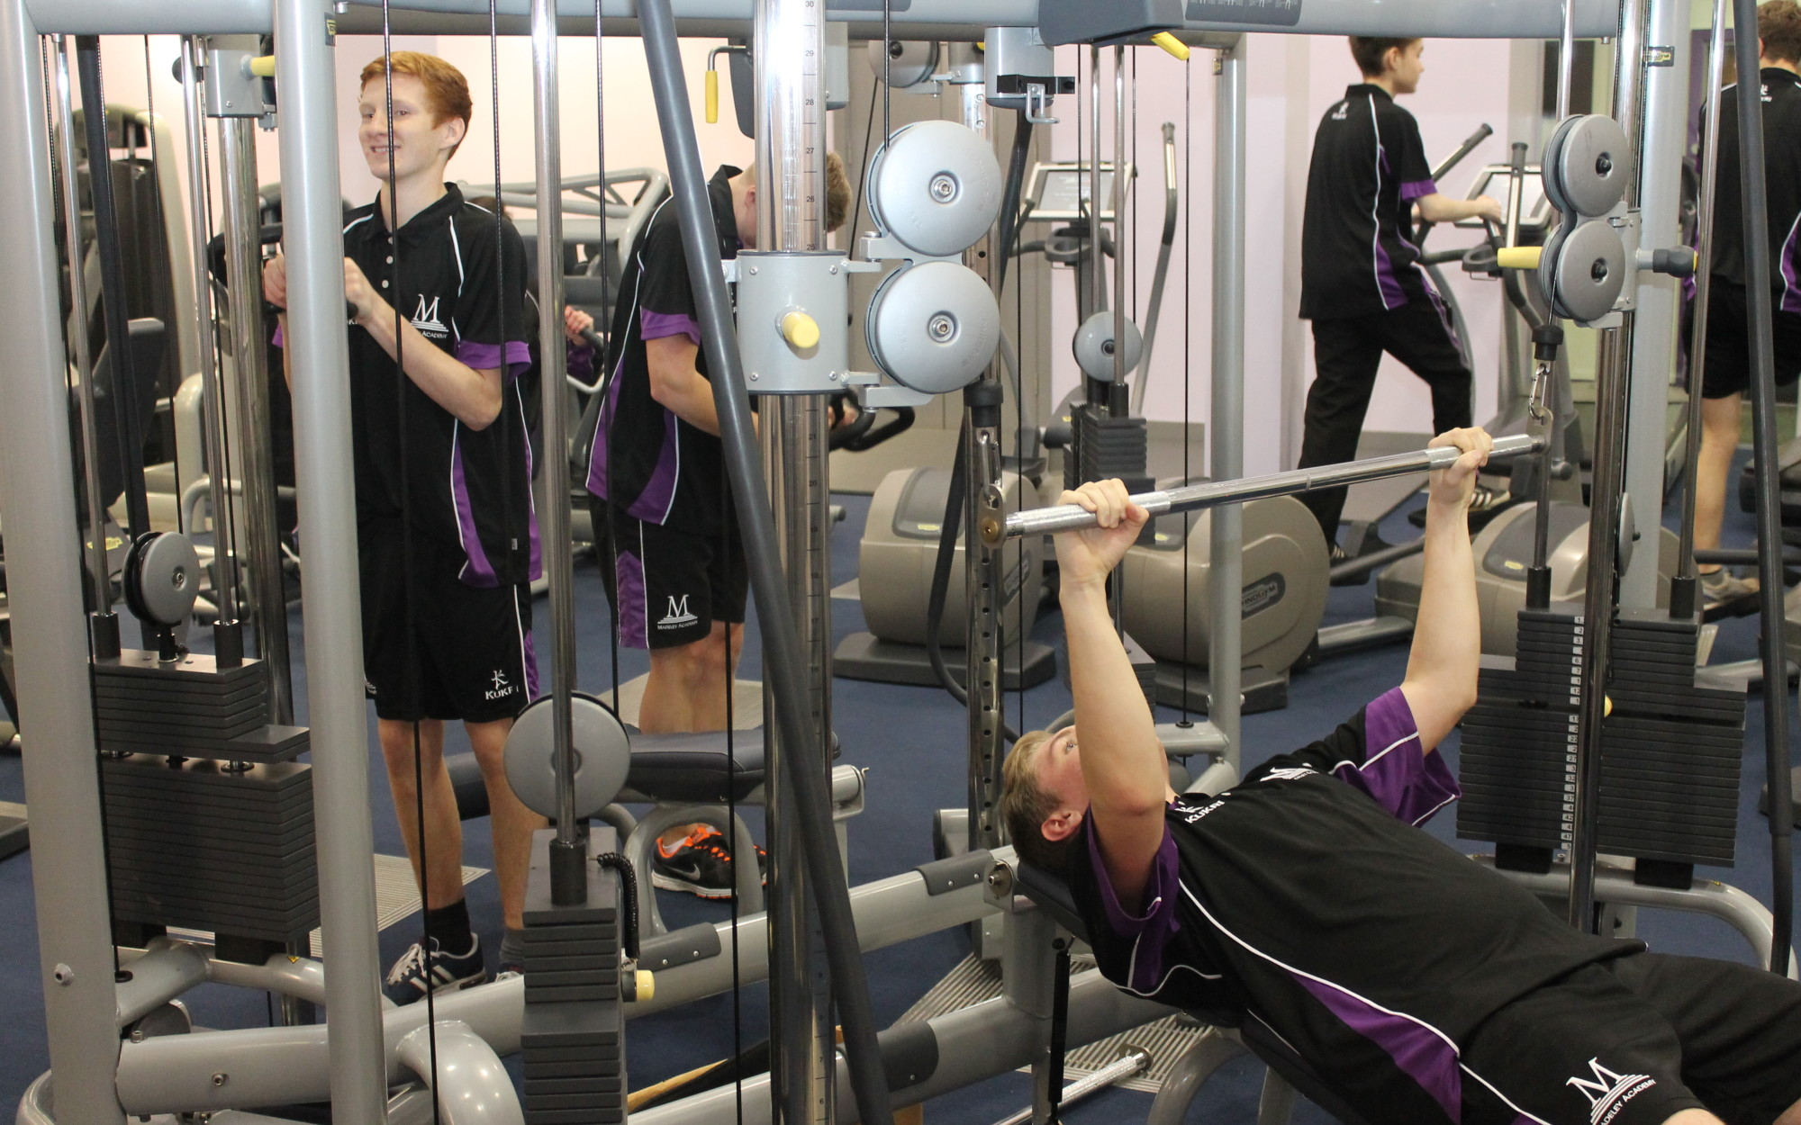
The School Day
Time | Activity
8.15am - 8:20am | Students arrive (Doors open at 8.20am prompt)
8:25am – 8.30am | Registration during 1A Lesson
8.30 – 10.10 | Lesson 1A (including 20-minute Break)
10:10am – 11.30am | Lesson 1B
11:30am – 1.40pm | Lesson 2A (including 30-minute lunch + tutor + PSHE tasks)
1:40pm – 2.50pm | Lesson 2B
2.50pm | Year 7 Dismissal (10 minutes before the remainder of the Academy)
3.00pm – 4.15pm | Session 3 Activities (Timetable to be available in September)
School Uniform
- Black blazer with academy badge
- White shirt or blouse
- School tie
- Black trousers or academy skirt
- Black socks or tights
- Plain black shoes or plain black trainers (no visible branding)
- Academy Bag (provided)
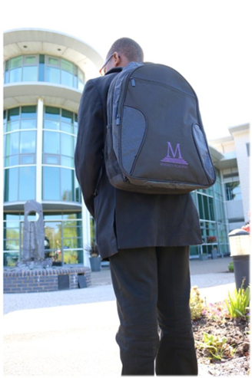
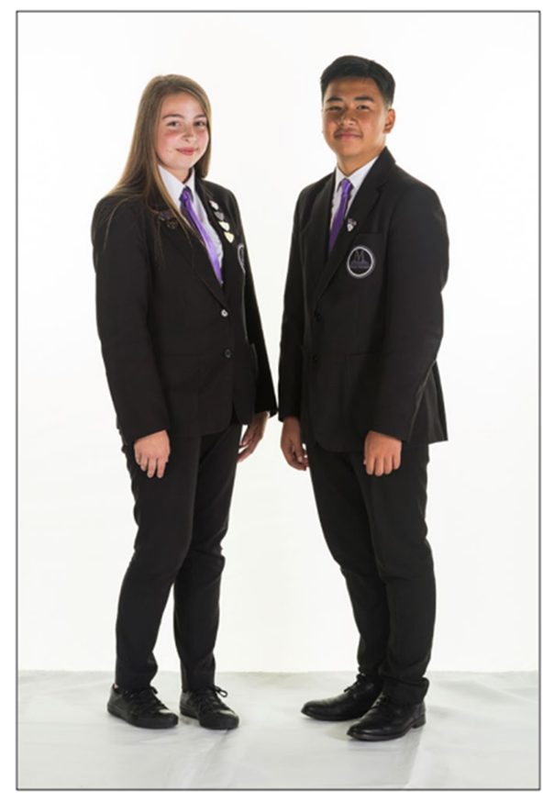

PE Kit
Academy PE polo shirt
PE shorts
Tracksuit (Top and Bottoms)
Trainers

All uniform and PE kit are available to purchase from Baker and Sons (Wellington)


Equipment for School
• Black pen
• Pencil
• Ruler
• Eraser
• Highlighter
• School bag


Subjects in Year 7
• English
• Maths
• Science
• History
• Geography
• Computing
• Art
• Music
• Design Technology
• Physical Education
• French

Transition Days
Students will visit the academy to help them settle in before September.

- Monday 6th July – Transition Day
- Tuesday 7th July – Transition Day
Further information regarding the transition days will be sent in advance. A member of staff from Madeley Academy will also be making a visit to all of the students at their primary school.

Key Staff Support
Any queries or concerns regarding Year 7 Transition, please contact:
Mr Hall – Deputy Headteacher
rhall@madeleyacademy.com

Contact
Madeley Academy
Castlefields Way, Madeley, Telford TF7 5FB
Phone: 01952 527700
Website: www.madeleyacademy.com

